Monthly Performance Report – October 2025
Kestrel Ridge Wind Farm (75.6 MW)
David Chen · 09 November 2025 · KR-OPS-RPT-2025-10

1. Summary
Kestrel Ridge generated 17.9 GWh in October 2025, 5.3 % below the P50 budget of 18.9 GWh. Time-based availability was strong at 97.5 % (contract target 97.0 %). Mean hub-height wind speed of 8.2 m/s was close to the long-term mean (8.3 m/s). Compared with October 2024 (19.0 GWh), output was down 1.1 GWh.

2. Production and key figures
KPI | October 2025 | Budget / target | YTD 2025 | YTD budget
Net generation (GWh) | 17.9 | 18.9 | 160.4 | 167.4
Time-based availability | 97.5 % | 97.0 % | 97.4 % | 97.0 %
Capacity factor | 31.8 % | 33.6 % | 29.1 % | –
Mean wind speed at hub height (m/s) | 8.2 | 8.3 | – | –
Source: Kestrel Ridge SCADA, revenue meter at 132 kV point of connection. Budget = P50 (2024 post-construction yield assessment).
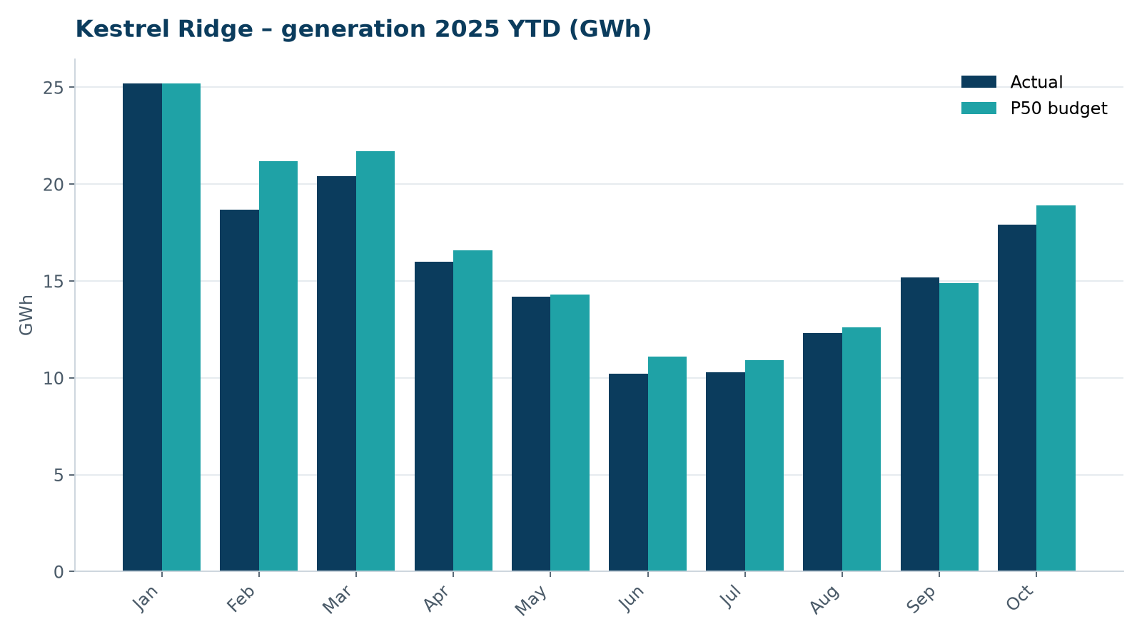
Monthly generation vs. P50 budget, 2025 year to date

3. Availability and downtime
Total turbine downtime attributable to the contractor amounted to 39 turbine-hours for the top events listed below. No grid or force majeure exclusions were claimed this month.
Turbine | Event | Downtime (h)
T-04 | pitch motor encoder fault on blade A | 18
T-16 | hydraulic oil leak at rotor brake caliper | 14
T-03 | service lift fault – lift locked out, turbine stopped for rescue cover | 7
Top downtime events of the month (SCADA event log, reviewed with Highline Wind Services).

4. Maintenance
- 24 corrective work orders closed, 3 still open at month end.
- Service lift six-monthly LOLER examinations completed on schedule.

5. Health, safety and environment
Indicator | Month
Hours worked on site (Highline + Weyland) | 3,151
Lost time injuries | 0
First aid cases | 0
Near misses reported | 2
Safety observations | 13
Environmental incidents | 0

No environmental incidents. Bird carcass searches were carried out on schedule (fortnightly, all turbines).

6. Outlook
Next month's focus: closing open corrective work orders and preparing the quarterly O&M review with Highline Wind Services.
Prepared by Sara Lindgren (Performance Analyst); reviewed by Ben Okoye (Site Manager) and David Chen (Asset Operations Manager).

